**Covid-19 Public Understanding for autistic people** - at this time, autistic people and their families may be facing more challenges than usual.

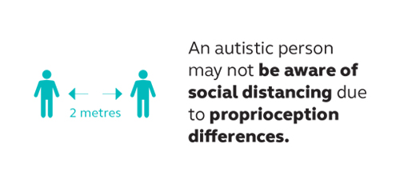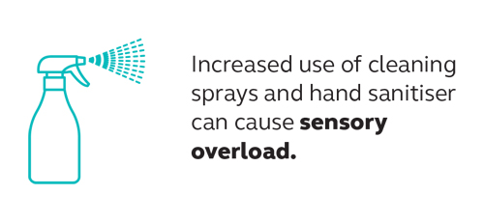

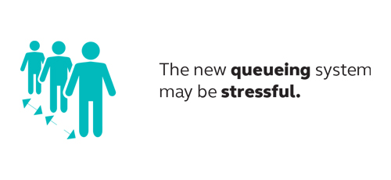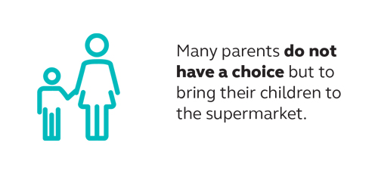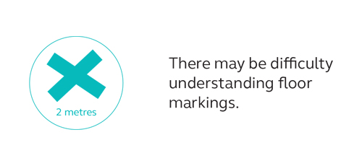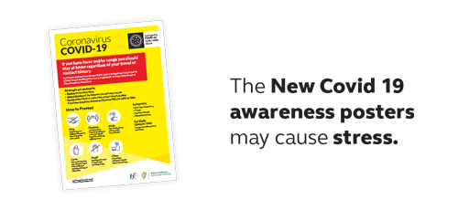

**How you can help:**

* Being patient, understanding, kind and non-judgemental
* Managing the social distancing yourself
* By not judging if you see or hear anyone finding the store experience overwhelming